Summary of Changes (v16.08)
- Replace wording “Sealed Bid Form” and “Sealed Proposal Form” with revised wording “Solicitation, Offer and Contract Form” to be consistent with the name of the form as used in Section TG 00410 and Section TG 00411.
- Clarify instructions for new or revised addendum specification sections.

Bidding Addenda Requirements | TG 00490
TECHNICAL GUIDE | TG 00490

1. Coordination Issues:
1.1 The information contained in and required by this section has serious contract implications. Ensure there are no errors in the final specification section.

1.2 Refer to Contract Conditions Article 6, Addendum/Pre-Contract Requirements for overall addenda requirements.

2. Design Issues: (Not Used)

3. Drawing Notes: (Not Used)

4. Standard Drawings: (Not Used)

5. Specification Notes: (Not Used)

6. Guide Specification:
6.1 Addendum Instructions, normally issued by Project Management Branch to Consultants during the Bidding Phase is included herein.

6.2 ADDENDUM FORMAT SAMPLES: Samples are attached. Edit as necessary,

SPECIFIER’S NOTE: Blue colored texts are Notes to the Specifier and should be completely deleted from the final text. Where [red colored text in brackets] is shown in this specification section, insert wording, numbers, etc. as appropriate and delete brackets. Where <Red colored text in brackets> is shown, choice is indicated. Make the appropriate choice and delete the brackets. Maintain footer notation in italics with the current version used. (e.g. TG-00490 v16.08).

Do not include the Project Name (etc.) line in the footer. Use the following format for the specification footer The Bidding Addenda requirement TG section and version number should be used throughout the addendum as applicable. Date should be expressed in MONTH DAY YEAR with numeric date in footer. Pages should be numbered with page number of total number of pages.

TG 00490 v16.08 Addendum No.1 (M/D/Y)
DAGS Job No. 00-00-0000 Page [1] of XX

End Footer Sample

SPECIFIER’S NOTE: If inserting new specification sections, use the TG section and version number of the inserted section if applicable. Also include the Addendum No. and date above the Name of Section. If the section (excluding the Solicitation, Offer and Contract Form) is revised, make sure to add “(Revised) after the section name. See SECTION TG 00490 – ADDENDUM FORMS for instructions regarding revisions to the Solicitation, Offer and Contract Form.
Addendum No.1 (M/D/Y)
TG 06070 v04.08 [Name of Section (Revised)]
DAGS Job No. 00-00-0000 Page 2 of XX

EXAMPLE of a new section:
Addendum No.1 (11/24/05)
TG 06070 v04.08 Wood Treatment
DAGS Job No. 00-00-0000 Page 1 of 7

End Footer Sample for Inserted Sections
Page 1 of 7

ADDENDUM INSTRUCTIONS
(To be given to the Architect/Engineer
when project is advertised)

Architect/Engineer:

1. Inform all subconsultants of pending bid opening and addenda deadline dates which will be given to the A/E as soon as the project is advertised (See attached ADDENDUM SCHEDULE).

2. Regarding Substitutions: (If applicable)

A. Reasons for disapproval must be clear, valid and in writing. Do not put down “does not meet specifications” but be specific as to where the product does not meet the specifications. D.A.G.S. has to justify each disapproval by calling and writing to the supplier prior to the last addendum.

B. No conditional approvals (approvals with provisions to be met) shall be given unless the Architect/Engineer is extremely confident that the conditions can and will be met as verified by the supplier. All conditions that substitutions must meet are to be typed onto the addendum specifications after the substitution brand name. For any approvals which may incur extra cost (size, shape, voltage, etc.) it shall be specifically written and stated that the contractor pays for the cost.

[Notes to Architect/Engineer: Comments you mark on the brochures are neither shown to nor read by the person(s) who is(are) making the substitution request.]

3. Addenda:

Avoid brand names in any addenda; however, if an item, material or equipment is required by the plans but not specified in the specifications, please issue an immediate addendum in order to allow all bidders sufficient time to properly submit competitive bids. If brand names must be specified for clarity, and substitutions before Bid Opening are being accepted other brand names will be allowed to post-qualify their products by including the following phrase:

"Other named manufacturers may post-qualify any manufacturer’s brand name specified hereinabove."

Check with your Project Coordinator.
Page 2 of 7

4. Typing of Addenda:

A. Start new page for each section (Plans, Specifications, Prequalified and Approved Substitutions) so that items can be added at the last minute without having to be retyped.

B. All changes by addenda to the Solicitation, Offer and Contract Form, even though minor in nature, will require new pages for the entire Solicitation, Offer and Contract Form. Each of these pages shall be labeled “REVISED Solicitation, Offer and Contract Form” with date. See SECTION TG 00490 – ADDENDUM FORMS for additional instructions regarding changes by addenda to the Solicitation, Offer and Contract Form.

C. When turning in addenda specifications, submit copy of same to facilitate the reading and checking.

5. Tracings:

A. All changes must be labeled and explained clearly on the drawing. Heavy cloud effect on the back of the tracing is required.

B. If change can be defined or explained in words only, omit tracing and write into addenda. This is to prevent excessive cost and bulk of printing and mailing addenda. Clarification drawings shall be issued during the construction period.

6. When project is advertised, Architect/Engineer and subconsultants are to obtain bid documents on the fourth floor of the Kalanimoku Building, Room 422. Fill in address labels so that all addenda may be mailed to you.

7. Architect/Engineer to start processing building permit as soon as bid documents are picked up. For projects with deadlines, the building permit process shall be initiated earlier. Check with your Project Coordinator.

8. Proper Communication During Bid:

Questions asked by the Contractors, subcontractors, suppliers and other interested parties shall be answered in a manner that will provide all bidders with the same information for competitive bidding and not give an unfair advantage or disadvantage to any party. Several types of questions can be categorized as follows:

A. Questions that can be answered by indicating where the information can be found on the plans and specifications shall be answered in that manner.

Page 3 of 7

B. Errors and/or omissions that can be taken under advisement. Inform caller that clarification and changes will be covered in an addendum if deemed necessary. No verbal interpretations are binding. In the event it is too late to issue an addendum, no interpretation shall be made. If the errors and/or omissions are major items, consideration shall be made to postpone or cancel said bid opening.

C. Questions that cannot be answered because they are too technical. You may refer caller to the appropriate subconsultant; however, with the understanding as noted under “A” and “B”. Do not refer to subconsultants if there is insufficient time to make any changes to the last addendum.

9. Others

For all addenda changes to tracings that will be copied onto 8-1/2 inch x 11 inch sheets, refer to the attached sample. The drawing should have a border and titles, page number, DAGS Job No., etc. on page bottom.

As a general rule, changes should be made on the tracings. However, if this format is used, the consultant will be required to submit a clarification Post Addendum Drawing at a later date at no additional cost to the State.

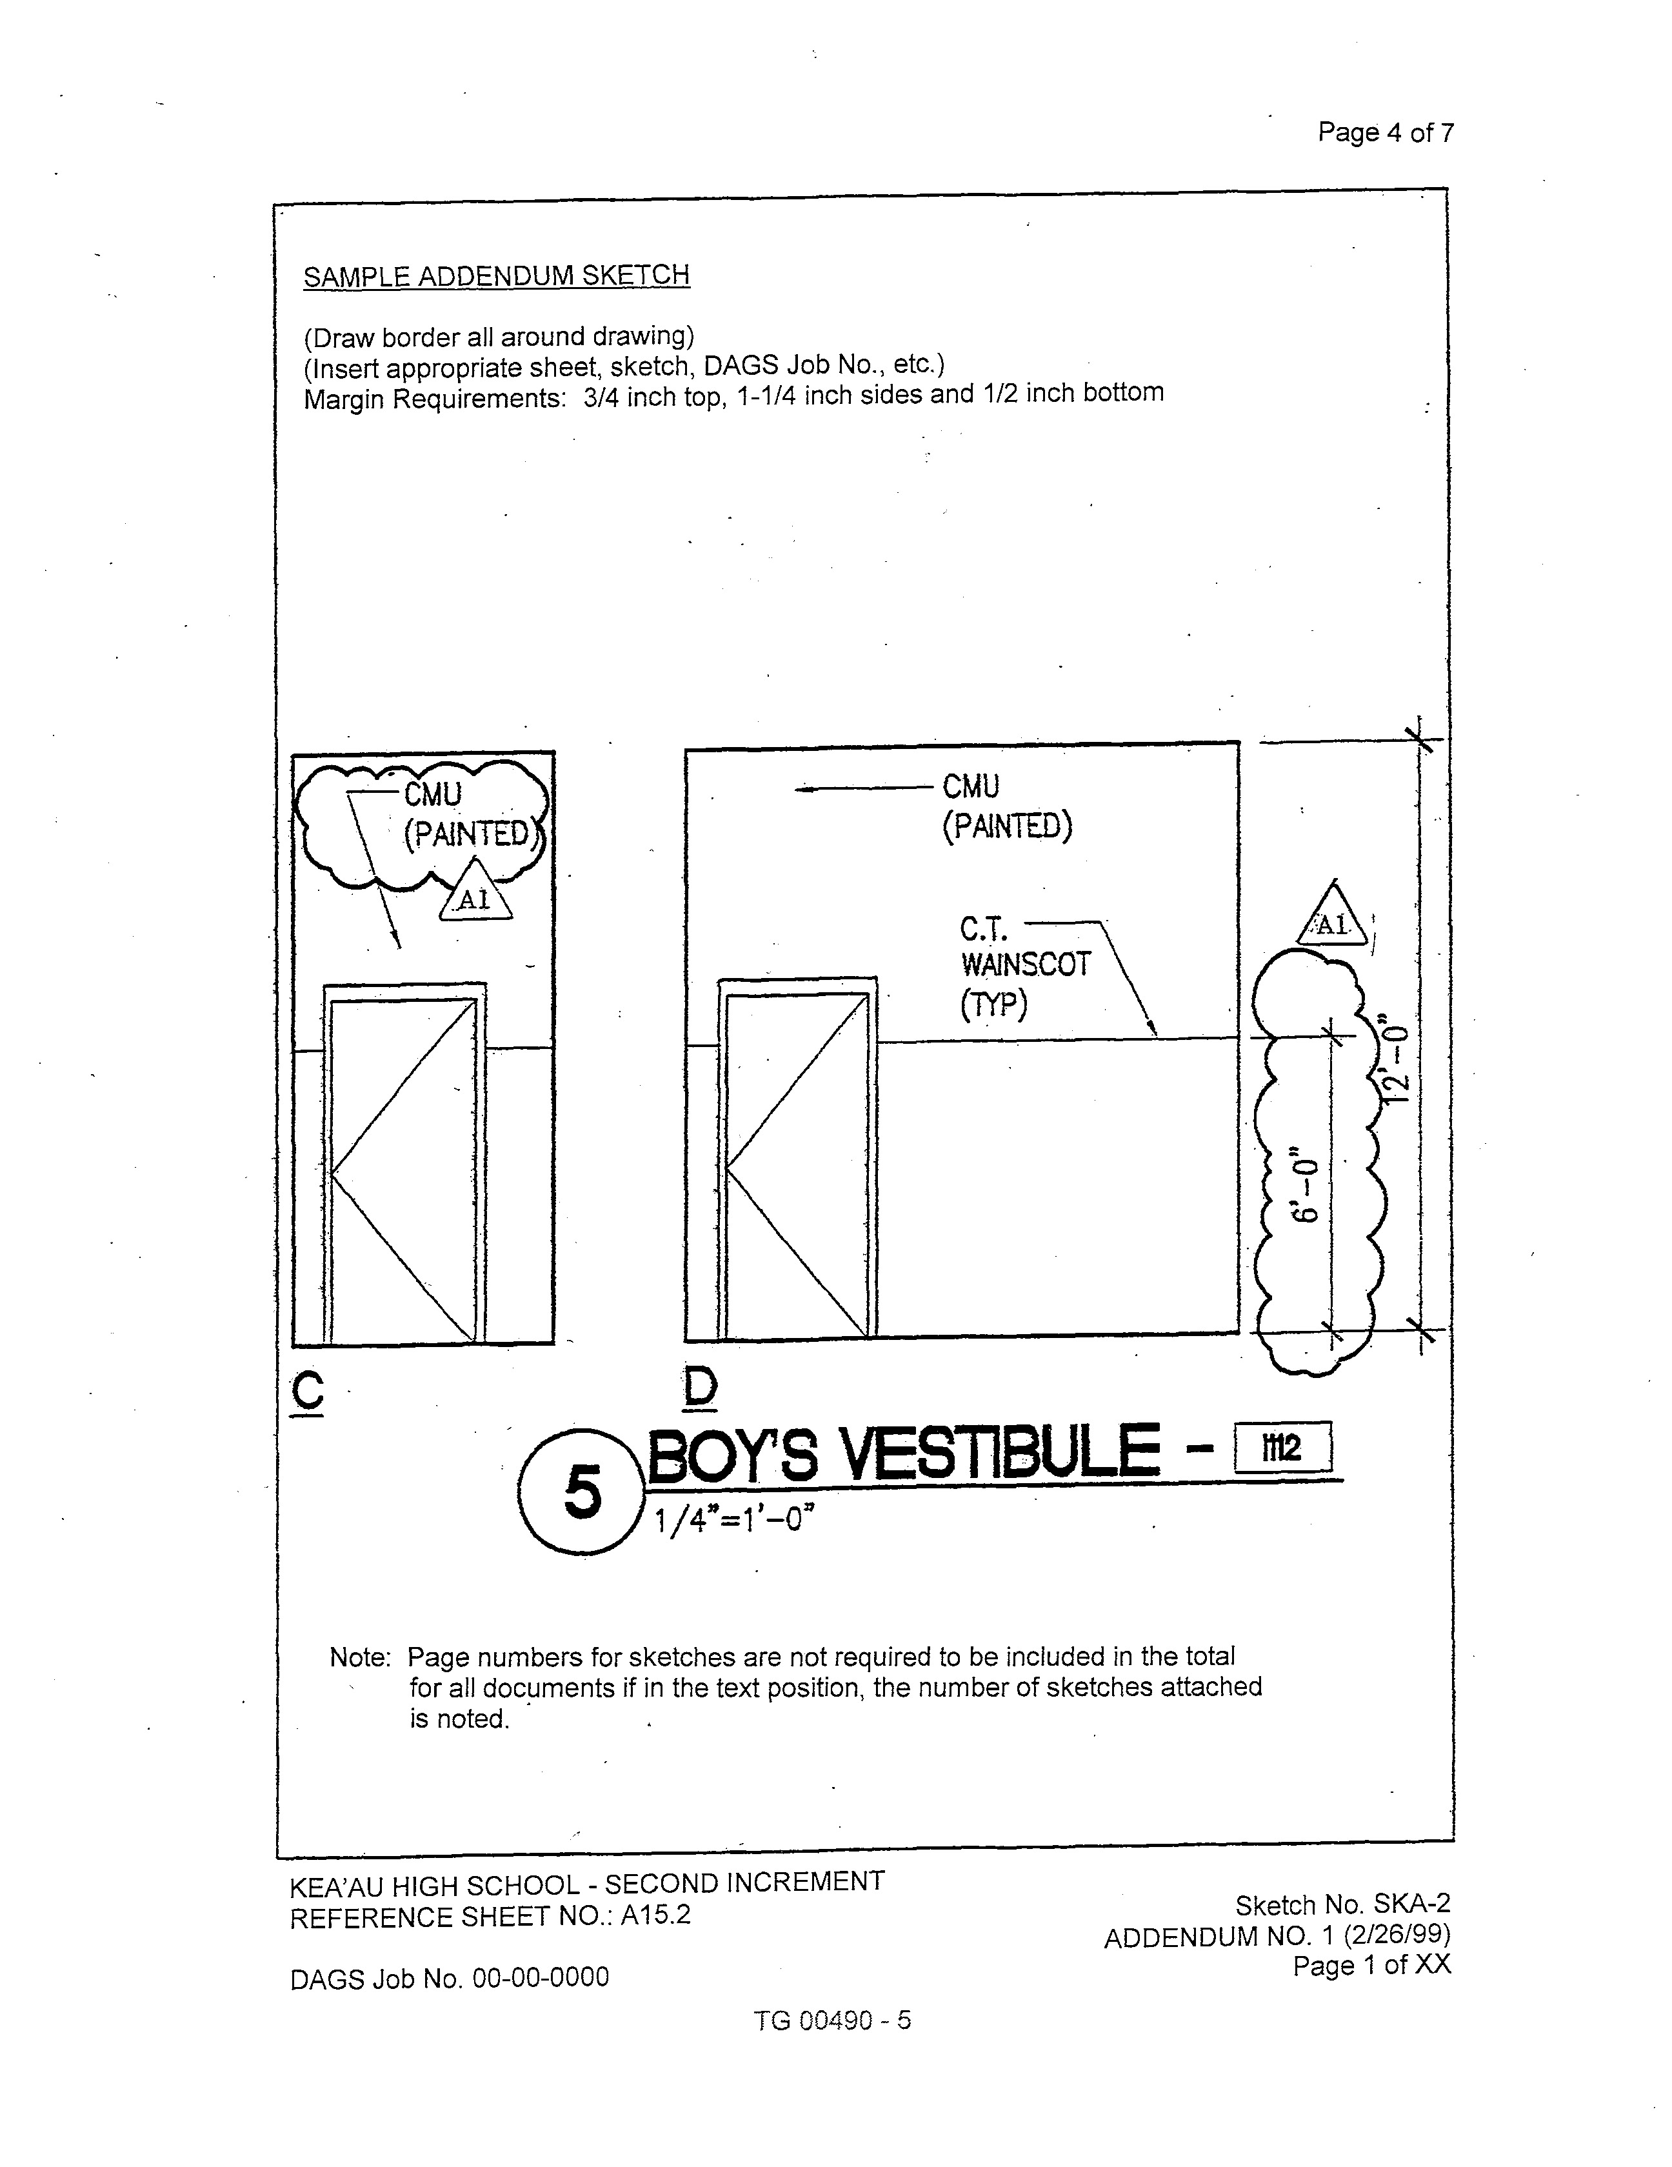
Page 4 of 7

INSERT

SAMPLE ADDENDUM SKETCH
(See pdf file "00490-5 Sample Addendum Sketch" for print-out)

Page 4
Page 5 of 7

GUIDELINES FOR
PREPARATION OF POST-CONTRACT DRAWINGS
AND ADDENDA

POST  ADD-1  7/ | A1 | CLARIFICATION ONLY 3/ |  | (NO)  OF 4/  (NO) | (DATE)  5/ | 6/
(PCD-1)  1/ | (1) | (DESCRIPTION OF POST-  CONTRACT DRAWING) 3/ |  | (NO)  OF 4/  (NO) | (DATE)  5/ | 6/
(ADD-1)  2/ | A1 | (DESCRIPTION  OF ADDENDUM) 3/ |  | (NO)  OF 4/  (NO) | (DATE)  5/ | 6/
REVISION  NO. | SYM. | DESCRIPTION |  | SHT ___ OF ___ | DATE | APPROVED:  PUBLIC WORKS ADMINISTRATOR
DEPT. OF ACCOUNTING AND GENERAL SERVICES
DIVISION OF PUBLIC WORKS
STATE OF HAWAII
 |  |  |  |  |  | DAGS JOB NO.  _________________ | DRAWING NO.
 |  |  | DESIGNED BY: | CHECKED BY: |  | DAGS JOB NO.  _________________ | DRAWING NO.
 |  |  | DRAWN BY: | APPROVED BY: |  | DATE  _________________ | SHEET  OF________ SHTS
 |  |  | SCALE: |  |  | DATE  _________________ | SHEET  OF________ SHTS

FILE ____________ DRAWER ____________ FOLDER ____________

Page 6 of 7

NOTES TO CONSULTANT

Notes printed in italics, brackets and footnotes are instructions only and should not be included on the drawing(s).

Clearly label and explain all change(s) on the drawing(s). Indicate change(s) on the drawing(s) with a heavy cloud effect and associated symbol/revision number on the back of the drawing(s). Drawing(s) with excessive changes should be replaced in its entirety to avoid confusion.

1/ Insert PCD-1 and delta symbol for post-contract drawing(s). PCD number and delta symbol number should be the same.

2/ Insert ADD-1 and delta with A1 symbol for addendum(s). Numbers should be the same.

3/ Describe change(s) made for each affected sheet.

4/ Insert sheet number and total number of sheet(s) associated with the addendum or post-contract drawing.

5/ Insert date of addendum or post-contract drawing. This date must be consistent with the date on title page of the addendum or post-contract drawing specifications.

6/ Leave first sheet’s approval block blank for each addendum or post-contract drawing. Cross out approval block for all subsequent sheet(s).

7/ Insert POST ADD-1 and delta with A1 symbol for addendum sketches. Number should be the same. These shall include addendum sketches and clarification only and shall be issued at the beginning of the project.

ADDITIONAL COMMENTS

1. POST ADD-1 and 2 can be combined; however, must be distinguished by the appropriate delta symbol No. 1 or 2.

2. For projects requiring CADD drawings, the PCD can be printed on vellum; however, the final record set submittal shall be on mylar.

3. Each PCD should be printed separately.

4. Consultant should maintain the tracings for projects done on CADD and submit the final updated set in accordance with SECTION 01770 – CLOSEOUT PROCEDURES, for the Contractor’s as-built changes.

Page 7 of 7

ADDENDUM SCHEDULE
(To be given to the Architect/Engineer
when project is advertised)

PROJECT: ________________________________________________________________
________________________________________________________________
DAGS JOB NO. _______________________________________________________________
1. Advertising Date: ________________________________________________________
2. Bid Opening Date: _______________________________________________________

3. Deadline for Substitutions: _________________________________________________
(As specified in SECTION 00800 - SPECIAL CONDITIONS)
4. Consultant”s deadline for addendum tracings: _________________________________
5. Consultant”s deadline for addendum specs: ___________________________________

6. DAGS deadline for sending out addenda: _____________________________________

Note: Items 4, 5 and 6 are deadlines for the last addendum. This does not preclude sending out addenda before that.

Other Comments:
_______________________________________________________________________________
_______________________________________________________________________________
_______________________________________________________________________________
_______________________________________________________________________________
______________________________________________________________________________
______________________________________________________________________________
_______________________________________________________________________________
_______________________________________________________________________________
_______________________________________________________________________________

