Summary of Changes (v18.08)
- Added to paragraph 1.01 Summary, subparagraph B.9 [internet services] as another option.
- Revision of paragraph 1.04 Quality Assurance to change from UBC code and respective wording to currently adopted IBC code and respective wording.
- Revision of paragraph 3.02.B Storm and Sewer Drainage to create paragraph 3.02.B Storm Drainage and paragraph 3.02.C Sewer Drainage to clarify that permits for Storm Drainage is handled by State Department of Health and for Sewer Drainage by respective environmental agency for each County.

Temporary Facilities and Controls  TECHNICAL GUIDE | TG 01500

- COORDINATION ISSUES:
  - The information contained in and required by this section has serious contract implications. Ensure there are no errors in the final specification section.
  - Coordinate with User for special temporary security measures, which might be required for renovation work in secure facilities.
  - The Project Coordinator is responsible for the information contained in this section. There are many provisions that require the Departments concurrence and approval.
- DESIGN ISSUES:
  - Projects for which item 3.04 ENVIRONMENTAL CONTROLS of this TG 01500 is applicable and that are located where neighbors may be impacted by site work, shall include the attached “Standard Detail for Dust Control Fence” as part of the design. Consultant shall show the fence locations on the project drawings. Consider at least the following:
    - Dust Control Fence Height
      - Minimum height: 12-feet.
      - Proximity of the neighbors. This may require that the height be increased;
      - If the height is increased, design consultant shall recalculate the support strength and redesign the Standard Detail accordingly;
    - Duration of the work;
    - Conditions of the soil at the site;
    - Anticipated site traffic; and
    - Applicable pollution control regulations.

- DRAWING NOTES:
  - Show layout of temporary conditions such as barriers, pedestrian or vehicular routes or access (egress, fire lanes, accessible routes) when critical to the project.
- STANDARD DRAWINGS:
  - See standard drawings attached to the end of this TG 01500.
- SPECIFICATION NOTES:
  - Edit the attached guide specification for scale and nature of the project. Remove requirements for projects of limited scope.
- GUIDE SPECIFICATION:
  - SECTION 01500 - TEMPORARY FACILITIES AND CONTROLS is attached: Add this section for all Projects.
SPECIFIER’S NOTE: Boxed blue colored text are Notes to the Specifier and should be completely deleted from the final text.

Where <red colored text in brackets> is shown in this specification section, insert wording, numbers, etc. as appropriate and delete brackets. Where [red colored text in brackets] is shown, choice is indicated. Make the appropriate choice and delete the brackets.

Maintain footer notation in italics with the current version used (e.g. TG 01500 v18.08). Verify that section titles cross referenced in this Section correspond to this Project’s specifications; Section titles may have changed.

Do not include the Project Name (etc.) line in the footer. Use the following format for the specification footer.

TG 01500 v18.08 Temporary Facilities and Controls
DAGS Job No. 00-00-0000 01500 - 1

End Footer Sample
SECTION 01500 - TEMPORARY FACILITIES AND CONTROLS
- GENERAL
      - SUMMARY
        - Requirements for temporary facilities and controls, including temporary utilities, support facilities, and security and protection facilities.
SPECIFIER’S NOTE: Edit lists in paragraphs 1.01 B. through 1.01 D. to meet project requirements.
        - Temporary utilities include but are not limited to, the following:
          - Sewers.
          - Storm drainage.
          - Water service and distribution.
          - Sanitary facilities, including toilets, wash facilities, and drinking water facilities.
          - Ventilation.
          - Electric power service.
          - Lighting.
          - Telephone service.
          - [Internet Service]
          - <Other service>
        - Support facilities include, but are not limited to, the following:
          - Project signs.
          - Field offices.
          - Storage and fabrication sheds.
          - Trash, refuse disposal.
          - Temporary roads and paving.
          - Erosion controls and site drainage.
          - [Lifts and hoists.]
          - [Temporary elevator usage.]
          - [Temporary stairs.]
          - [Construction aids and miscellaneous services and facilities.]
          - <Insert special temporary support facility if required.>
        - Security and protection facilities and measures include, but are not limited to, the following:
          - Environmental protection.
          - Stormwater control.
          - Tree and plant protection.
          - Site enclosure fence.
          - Barricades, warning signs, and lights.
          - Pest control.
          - [Security enclosure and lockup.]
          - [Covered walkways.]
          - [Temporary enclosures.]
          - [Temporary partitions.]
          - [Fire protection.]
          - [Temporary security measures.]
          - <Insert special temporary security and protection facility if required.>
        - Related Sections: Refer to Divisions 2 through 16 for other temporary requirements including ventilation, humidity requirements and products in those Sections.
SPECIFIER’S NOTE: Confirm utility use with Project Coordinator.
      - USE CHARGES
        - General: Cost or use charges for temporary facilities are not chargeable to the State and shall be included in the Contract Price. Allow other entities to use temporary services and facilities without cost, including, but not limited to, the following:
          - Other Contractors with agreements with the State working within the contract limits.
          - Occupants of Project.
          - Testing agencies.
          - Contracting Officer and personnel of authorities having jurisdiction.
      - SUBMITTALS
        - Temporary Utility Reports: Submit reports of tests, inspections, meter readings, and similar procedures performed on temporary utilities.
        - Landfill Disposal Receipts: Submit copies of receipts issued by a landfill facility. Include receipts with Contractor Daily Progress Report
      - QUALITY ASSURANCE
        - Standards: Comply with IBC Chapter 33, “Safeguards During Construction”, ANSI A10.6, NECA’s “Standard for Installing and Maintaining Temporary Electric Power at Construction Sites”, and NFPA 241, "Standard for Safeguarding Construction, Alteration, and Demolition Operations".
          - Trade Jurisdictions: Assigned responsibilities for installation and operation of temporary utilities are not intended to interfere with trade regulations and union jurisdictions.
          - Electric Service: Comply with NECA, NEMA, and UL standards and regulations for temporary electric service. Install service to comply with NFPA 70, “National Electrical Code”.
            - Tests and Inspections: Arrange for authorities having jurisdiction to test and inspect each temporary utility before use. Obtain required certifications and permits.
      - PROJECT CONDITIONS
        - Temporary Utilities: At earliest feasible time, when acceptable to the Contracting Officer, change over from use of temporary service to use of permanent service.
          - Temporary Use of Permanent Facilities: Installer of each permanent service shall assume responsibility for operation, maintenance, and protection of each permanent service during its use as a construction facility before Contracting Officer’s acceptance, regardless of previously assigned responsibilities.
        - Conditions of Use: The following conditions apply to use of temporary services and facilities by all parties engaged in the Work:
          - Keep temporary services and facilities clean and neat.
          - Relocate temporary services and facilities as required by progress of the Work.
      - PREPARATION AND PROTECTION
        - Protection of Property: Continually maintain adequate protection of the Work from damage and protect all property, including but not limited to buildings, equipment, furniture, grounds, vegetation, material, utility systems located at and adjoining the job site. Repair, replace or pay the expense to repair damages resulting from Contractor’s fault or negligence.
        - Before starting work to be applied to previously erected constructions, make a thorough and complete investigation of the recipient surfaces and determine their suitability to receive required additional construction and finishes. Make any repair that is required to properly prepare surfaces, and coordinate the Work to provide a suitable surface to receive following Work.
        - Commencing work by any trade implies acceptance of existing conditions and surfaces as satisfactory for the application of subsequent work, and full responsibility for finished results and assumption of warranty obligations under the Contract.
        - Protect existing (including interiors) work to prevent damage by vandals or the elements. Provide temporary protection. Use curtains, barricades, or other appropriate methods. Take positive measures to prevent breakage of glass and damage to plastic, aluminum and other finishes.
        - Repairs and Replacements: Promptly replace and repair damages to the approval of the Contracting Officer. Additional time required to secure replacements and to make repairs does not justify a time extension.
- PRODUCTS
      - MATERIALS
        - General: Provide new materials. Undamaged, previously used materials in serviceable condition may be used if approved by Contracting Officer. Provide materials suitable for use intended.
SPECIFIER’S NOTE: Select appropriate section (asphalt, concrete, gravel) if temporary paving is required.
        - Pavement: Comply with Section <INSERT NUMBER AND TITLE>.
SPECIFIER’S NOTE: Delete paragraphs 2.01 C. and 2.01 D. if wood fence or covered walkway is used. For more security, increase fence height to 8-feet and revise size of posts. If appearance is important for highly visible projects, revise paragraphs to require new materials; otherwise, Contractor is likely to provide reused material. UBC Section 3303 requires barricades depending on proximity of barricade to exterior wall of the project or public way.
        - Chain Link Fencing: Minimum 2 inch, 9-gage, galvanized steel, chain link fabric fencing; minimum 6-feet high with galvanized steel pipe posts; minimum 2 3/8 inch OD line posts and 2 7/8 inch OD corner and pull posts [, with 1 5/8 inch OD top rails] [, with galvanized barbed wire top strand].
        - Portable Chain Link Fencing: Minimum 2 inch 9 gage, galvanized steel, chain link fabric fencing; minimum 6-feet high with galvanized steel pipe posts; minimum 2 3/8 inch OD line posts and 2 7/8 inch OD corner and pull posts, with 1 5/8 inch OD top and bottom rails. Provide [concrete] [galvanized steel] bases for supporting posts.
        - Wood Enclosure Fence: Plywood, [6-feet] [8-feet] high, framed with four 2 by 4 inch rails, with preservative treated wood posts spaced not more than 8-feet apart.
          - Lumber and Plywood: Comply with requirements in SECTION 06100 - ROUGH CARPENTRY.
        - Plastic Enclosure Fence: Industry standard 4-feet high plastic fencing with metal (or wood) post supports at 10-feet on center connected with a top and bottom 12-gauge soft annealed galvanized tie wires securely connected to posts. Posts shall be capable of resisting a lateral load of 100 pounds measured at the top of the post.
SPECIFIER’S NOTE: Delete paragraph 2.01 G. if mobile or prefabricated office units are specified.
        - Roofing: Standard weight, mineral surfaced, asphalt shingles or asphalt impregnated and coated, mineral surfaced, roll roofing sheet.
SPECIFIER’S NOTE: Retain paragraph2.01 H. for job built office units or if gypsum board temporary partitions for enclosure or dust control are specified.
        - Gypsum Board: Minimum 1/2-inch thick by 48-inches wide by maximum available lengths; regular type [fire rated Type X] panels with tapered edges complying with ASTM C 36.
SPECIFIER’S NOTE: Retain paragraph 2.01 I. for insulated temporary enclosures and partitions.
        - Insulation: Unfaced mineral fiber blanket, manufactured from glass, slag wool, or rock wool; or aluminum faced bubble wrap insulation radiant barrier with maximum flame spread and smoke developed indices of 25 and 50, respectively.
        - Paint: Comply with requirements in [SECTION 09901 - PAINTING] [SECTION 09902 - REPAINTING].
        - Tarpaulins: Fire resistive labeled with flame spread rating of 15 or less.
        - Water: Potable.
SPECIFIER’S NOTE: Include for large ($5 M and larger) new and renovation projects. Confirm requirements for Contractor’s field office and DAGS field office with the Project Coordinator.
      - EQUIPMENT
        - Field Offices:
          - Prefabricated or job built construction with lockable entrances, operable windows, and serviceable finishes; air conditioned; insulated; 90-inch minimum height to ceiling; and on foundations adequate for normal office loading.
          - Provide the following for job built construction:
            - Light gage steel or wood stud grade framing and fire treated plywood or non-combustible composite panels.
              - Interior painting required; exterior painting not required.
              - Roofs: Metal sheet, asphalt shingles or roll roofing and insulated or with radiant barriers.
              - Door Hardware: Same as provided elsewhere on the construction project.
SPECIFIER’S NOTE: Delete for existing building where adequate fire extinguishers exist and flame or hot work is not being done.
        - Fire Extinguishers: Hand carried, portable, UL rated. Provide class and extinguishing agent as indicated or a combination of extinguishers of NFPA recommended classes for exposures. Comply with NFPA 10 and NFPA 241 for classification, extinguishing agent, and size required by location and class of fire exposure.
SPECIFIER’S NOTE: Delete when Contractor may use existing facility toilets.
        - Self Contained Combination Toilet and Urinal Units: Single occupant units of chemical, aerated recirculation, or combustion type; vented; fully enclosed with a glass fiber reinforced polyester shell or similar nonabsorbent material. One quarter of, or at least one unit(s) shall contain a handwash sink with potable water storage.
SPECIFIER’S NOTE: Delete when Contractor may use existing water fixtures.
        - Drinking Water Fixtures: Drinking water fountains or containerized, tap dispenser, bottled water drinking water units, or water cooler dispensing water at 45 - 55 degree F available at [Field Office(s)] [project site] including paper cup supply.
        - Electrical Outlets: Properly configured, NEMA polarized outlets to prevent insertion of 110 to 120 V plugs into higher voltage outlets; equipped with ground fault circuit interrupters, reset button, and pilot light.
        - Power Distribution System Circuits: Where permitted and overhead and exposed for surveillance, wiring circuits, not exceeding 125 V ac, 20 A rating, and lighting circuits may be nonmetallic sheathed cable.
SPECIFIER’S NOTE: Modify paragraph 2.02 G. and subparagraphs to meet Project’s needs. Use subparagraph 2.02 G. 3. for major complex projects when DAGS (or CM) staff will work out of the jobsite office with computer access. Confirm with Project Coordinator.
        - Data and Communication: Provide service and equipment throughout construction period. [Install separate equipment and service for the Department’s field office for the items noted below] [Allow the Department’s Inspector use of equipment.]
          - Provide a facsimile machine at Contractor’ field office [and the Department’s Field Office.]
          - Provide plain paper copier, automatic feed, collating capabilities and printing up to 11-inch by 17-inch sheets at Contractor’ field office [and the Department’s Field Office.]
          - Computer Internet Connection: Provide a high-speed connection (landline satellite or wireless), capable to connect to multiple users at the Department’s Field Office. Connection shall be separate from the telephone service.
- EXECUTION
      - INSTALLATION, GENERAL
        - Locate facilities where they will serve Project adequately and result in minimum interference with performance of the Work. Relocate and modify facilities as required.
          - Secure approval from Contracting Officer before modifications are made to the State Inspector’s Field Office.
        - Provide each facility ready for use when needed to avoid delay. Maintain and modify as required. Do not remove until facilities are no longer needed or are replaced by authorized use of completed permanent facilities.
      - TEMPORARY UTILITY INSTALLATION
SPECIFIER’S NOTE: Select paragraph A. as applicable.
        - [General: Engage appropriate local utility company to install temporary service or connect to existing service where directed by the Contracting Officer. Where utility company provides only part of the service, provide the remainder with matching, compatible materials and equipment. Comply with utility company recommendations.] [General: Connect to existing service where directed by the Contracting Officer.]
          - Arrange with utility company, the Department, and existing users for time when service can be interrupted, if necessary, to make connections for temporary services.
          - Provide adequate capacity at each stage of construction. Before temporary utility is available, provide trucked in services.
        - Storm Drainage: Drainage due to construction related activities into any storm drain and any major water runoff from the project site is generally prohibited. Drainage ditches, ponds or similar facilities capable of holding drainage water is recommended if possible. NPDES (National Pollutant Discharge Elimination System) permit is required for a project site one acre or more of land area (depending on configuration of a project site, it is possible that land area assumed to be less than one acre could be determined to be one acre or more and require a NPDES permit). Supporting documents such as Storm Water Pollution Control Plan, Spill Prevention and Response Plan, Storm Water Monitoring Plan, Best Management Practices Plan and other possible documents may be required for the permit application. The State Department of Health, Clean Water Branch should be contacted to determine all submission requirements for the permit application.
        - Sewer Drainage: The respective environmental departments regulating wastewater for each County should be contacted to obtain a wastewater discharge permit if there is any intention to discharge effluents into any existing sewer manhole or to make a piping connection into any existing sewer line, if allowed by the County. A construction permit application may also be required if the intent is to make a temporary piping connection into the existing sewer line if the initial permit application for the project and associated design documents submitted did not include these details. There are regulations to determine what effluents may or may not be allowed to be discharged into the existing sewer system with temporary filtration, separators or other devices determined to be acceptable.
SPECIFIER’S NOTE: Confirm if Contractor will be allowed temporary use of or connections to State facilities. Modify or edit paragraph 3.02 D. accordingly. Where Contractor may use facility water without charge, delete second paragraph 2 thru 6 and renumber.
        - Water Service: Make arrangements with the utility company for temporary use of water, and pay for all expenses. [However, at the option of the Contractor, a temporary tap into the facility’s existing water system is allowed, subject to the following conditions:]
          - Comply with the Department of Health’s and County water provider’s requirements when tapping into the existing water system.
          - [Reasonable amounts of water will be available without charge.]
          - Meter the tapped line and prior to water use, notify the Contracting Officer to observe an initial meter reading.
          - Take monthly meter readings. Pay the State, on a monthly basis, for water used at the current rate per 1,000 gallons.
          - Payments are to be by check, made payable to the “Director of Finance, State of Hawaii” and mailed as directed by the Contracting Officer:
          - Checks shall be accompanied by the following information:
            - Name of facility, Project Name and Title and DAGS Job No.
            - Contractor’s name
            - Initial meter reading for the month and final meter reading for the month.
            - Volume of water used and the amount due in payment for that water
          - Upon completion of the project and just prior to removal of the water meter, notify the Contracting Officer to observe a final meter reading.
          - Should the Contractor at any time fail to comply with any or all of the above conditions, the Department may terminate the use of water. The Contractor shall remove the hookup within 48 hours of notification of such termination.
        - Sanitary Facilities: Provide temporary toilets, wash facilities, and drinking water fixtures. Comply with regulations and health codes for type, number, location, operation, and maintenance of fixtures and facilities.
          - Disposable Supplies: Provide toilet tissue, paper towels, paper cups, and similar disposable materials for each facility. Maintain adequate supply. Provide covered waste containers for disposal of used material.
SPECIFIER’S NOTE: Retain applicable subparagraph 3.02 E. 2. and delete the other subparagraph. If State facilities are not available or their use is not permitted even if available use the self contained units. Indicate location of existing toilets on Drawings. Retain clause 3.02 E. 3. a. if required by authorities or recommended for health and safety reasons if not already part of a DIVISION 13 technical section.
          - [Toilets: Use of user’s existing toilet facilities will be permitted where and when directed by the Contracting Officer, as long as facilities are cleaned and maintained in a condition acceptable to user. At Substantial Completion, restore these facilities to condition existing before initial use. Provide separate facilities for male and female personnel.] [Toilets: Install self contained toilet units. Shield toilets to ensure privacy. Provide separate facilities for male and female personnel.]
          - Wash Facilities: Install wash facilities supplied with potable water at convenient locations for personnel who handle materials that require wash up. Dispose of drainage properly. Supply cleaning compounds appropriate for each type of material handled.
            - [Provide safety showers, eyewash fountains, and similar facilities for convenience, safety, and sanitation of personnel.]
          - Locate toilets and drinking water fixtures so personnel need not walk more than 2 stories vertically or 200-feet horizontally to facilities.
        - Ventilation and Humidity Control: Provide temporary ventilation required by construction activities for curing or drying of completed installations or for protecting installed construction from adverse effects of high humidity. Select equipment that will not have a harmful effect on completed installations or elements being installed. Coordinate ventilation requirements to produce ambient condition required and minimize energy consumption.
SPECIFIER’S NOTE: Confirm if Contractor will be allowed temporary use of or connection to State facilities. Modify or edit paragraph 3.02 G. accordingly.
        - Electric Power Service: Provide weatherproof, grounded electric power service and distribution system of sufficient size, capacity, and power characteristics during construction period. Include meters, transformers, overload protected disconnecting means, automatic ground fault interrupters, and main distribution switchgear. [Use of State facilities electrical power services will be permitted as long as equipment is maintained in a condition acceptable to the Contracting Officer.] [Make arrangements with utility companies for temporary use of electricity for construction use. Pay for all expenses pertaining thereto.] [Use of State facilities electrical power services will be permitted as long as equipment is maintained in a condition acceptable to the Contracting Officer.]
        - Electric Distribution: Provide receptacle outlets adequate for connection of power tools and equipment. Protect wiring, in conduits or other, measures when exposed to possible damage or traffic areas.
        - Lighting: Provide temporary lighting with local switching that provides adequate illumination for construction operations and traffic conditions.
SPECIFIER’S NOTE: Revise list in subparagraph 3.02 J. 2. to suit Project. Use second paragraph K. when no field office is required.
        - [Telephone Service: Provide temporary telephone service throughout construction period for common use facilities used by all personnel engaged in construction activities. Install separate telephone line for the Department’s field office and each Contractor’s field office and first aid station.
          - At DAGS field office, provide land-line telephone service or if approved by the Contracting Officer, wireless (digital or cellular) telephone service. Provide internet service with ISP with unlimited access. Provide broadband where available.
          - At each telephone, post a list of important telephone numbers.
            - Police and fire departments,
            - Ambulance service,
            - Contractor’s home office,
            - Contract contacts,
              - Subcontractors
              - Suppliers
            - Department Staff contacts,
              - Construction Coordinator
              - Inspector
            - State’s Emergency contacts,
              - Construction Coordinator after hours
              - Inspector after hours
            - Principal Subcontractors’ field and home offices,
            - User’s office and emergency.
          - Provide a portable wireless telephone with voice-mail or messaging service for superintendent’s use in making and receiving telephone calls when away from field office.]
        - [Telephone Service: Provide a portable wireless telephone with voice-mail or messaging service for superintendent’s use in making and receiving telephone calls when at the construction site.]
SPECIFIER’S NOTE: For phased construction projects, confirm requirements to be implemented with Project Coordinator. Modify the paragraphs to suit the Project. Make sure the provisions of subparagraph 3.03 A. 3. are acceptable to the Use; otherwise delete the subparagraph.
      - SUPPORT FACILITIES INSTALLATION
        - General: Comply with the following:
          - Locate field offices, storage sheds, sanitary facilities, and other temporary construction and support facilities for easy access or where shown on Contract Drawings or as directed by the Contracting Officer.
          - Maintain support facilities until near Substantial Completion. Remove before Substantial Completion.
          - [Personnel remaining after Substantial Completion will be permitted to use permanent facilities, under conditions acceptable to State.]
        - Temporary Roads and Paved Areas: Construct and maintain temporary roads and paved areas adequate to support loads and to withstand exposure to traffic during construction period. Locate temporary roads and paved areas as indicated on Drawings.
          - Provide a reasonably level, graded, well drained subgrade of satisfactory soil material, compacted to not less than 95 percent of maximum dry density in the top 6 inches.
          - Provide gravel paving course of subbase material not less than 3-inches thick; roller compacted to a level, smooth, dense surface.
          - Provide dust control treatment that is nonpolluting and nontracking. Reapply treatment as required to minimize dust.
        - Traffic Controls: Provide temporary traffic controls at junction of temporary roads with public roads. Include warning signs for public traffic and “STOP” signs for entrance onto public roads. Comply with requirements of authorities having jurisdiction.
        - Site Drainage:
          - Dispose of rainwater in a lawful manner that will not result in flooding Project or adjoining property nor endanger permanent Work or temporary facilities.
          - Before connection and operation of permanent drainage piping system, provide temporary drainage where roofing or similar waterproof deck construction is completed.
SPECIFIER’S NOTE: Coordinate sign requirements with DCC Manual. Add or modify sign requirements to suit project.
        - Project Sign and Temporary Sign(s):
          - Provide and install project identification sign and other signs as listed. Sign designs are attached to Part 3 of this Section:
            - Project Sign
            - [Warning Sign]
          - Install signs where directed by the Contracting Officer or where indicated to inform public and persons seeking entrance to the Project. Do not permit installation of unauthorized signs.
          - Provide temporary signs to provide directional information to constructional personnel and visitors.
          - Construct signs with durable materials, properly supported or mounted, and visible.
        - Trash, Refuse Disposal:
          - Department of Health – Illegal Dumping Notice. See attachment to Part 3 of this section.
            - This Notice to be printed out on 8.5x11” paper.
            - This Notice to be posted at the job site field office and/or in locations visible to all contractors, subcontractors, suppliers, vendors, etc. throughout the duration of the project.
          - Illegal Dumping of solid waste could subject the Contractor to fines and could lead to felony prosecution in accordance with Chapter 342H, HRS. For more information, see the following web site: http://www.hawaii.gov/health/environmental/waste/sw/pdf/Illdump.pdf
          - Provide waste collection containers in sizes adequate to handle waste from construction operations. Containerize and clearly label hazardous, dangerous, or unsanitary waste materials separately from other waste.
          - Do not burn debris or waste materials on the project site.
          - Do not bury debris or waste material on the project site unless specifically allowed elsewhere in these specifications as backfill material.
          - Haul unusable debris and waste material to an appropriate off site dump area.
            - Water down debris and waste materials during loading operations or provide other measures to prevent dust or other airborne contaminants.
            - Vacuum, wet mop, or damp sweep when cleaning rubbish and fines which can become airborne from floors or other paved areas. Do not dry sweep.
            - Use enclosed chutes or containers to conveying debris from above the ground floor level.
          - Clean up shall include the collection of all waste paper and wrapping materials, cans, bottles, construction waste materials and other objectionable materials, and removal as required. Frequency of clean up shall coincide with rubbish producing events.
        - Janitorial Services: Provide janitorial services on a weekly basis for the Contracting Officer’s field office, first aid stations, toilets, wash facilities, lunchrooms, and similar areas.
SPECIFIER’S NOTE: Modify or delete paragraphs 3.03 H. through 3.03 K. below if elevators or stairs are not available or their use is restricted or not permitted even if available. Indicate location of existing elevators on Drawings.
        - Temporary Elevator Usage: Refer to SECTION <_______ - ______________> for temporary use of new elevators.
        - Existing Elevator Usage: Use of existing elevators will be permitted, as long as elevators are cleaned and maintained in a condition acceptable to State and User. At Substantial Completion, restore elevators to condition existing before initial use[, including replacing worn cables, guide shoes, and similar items of limited life].
          - Provide protective coverings, barriers, devices, signs, or other procedures to protect elevator car and entrance doors and frame. If, despite such protection, elevators become damaged, engage elevator Installer to restore damaged work so no evidence remains of correction work. Return items that cannot be refinished in field to the shop, make required repairs and refinish entire unit, or provide new units as required.
        - Temporary Stairs: Until permanent stairs are available, provide temporary stairs where ladders are not adequate. Cover finished, permanent stairs with protective covering of plywood or similar material so finishes will be undamaged at time of acceptance.
        - Existing Stair Usage: Use of existing stairs will be permitted, as long as stairs are cleaned and maintained in a condition acceptable to State and User. At Substantial Completion, restore stairs to condition existing before initial use.
          - Provide protective coverings, barriers, devices, signs, or other procedures to protect stairs and to maintain means of egress. If, despite such protection, stairs become damaged, restore damaged areas so no evidence remains of correction work.
      - ENVIRONMENTAL CONTROLS
        - General: Provide protection, operate temporary facilities, and conduct construction in ways and by methods that comply with environmental regulations and that minimize possible air, waterway, and subsoil contamination or pollution or other undesirable effects.
        - Dust Control:
          - Prevent dust from becoming airborne at all times including non working hours, weekends and holidays in conformance with the State Department of Health, Administrative Rules, Title 11, Chapter 60.1 Air Pollution Control.
          - Contractor is responsible for and shall determine the method of dust control. Subject to the Contractor’s choice, the use of water or environmentally friendly chemicals may be used over surfaces that create airborne dust.
          - Contractor is responsible for all damage claims due to their negligence to control dust.
SPECIFIER’S NOTE: When required by site work and neighboring property conditions, construct a dust control fence in accordance with attached Details E and F/TG 01500.
        - Noise Control
          - Keep noise within acceptable levels at all times in conformance with the State Department of Health, Administrative Rules, Title 11, Chapter 46 Community Noise Control. Obtain and pay for the Community Noise Permit when construction equipment or other devices emit noise at levels exceeding the allowable limits.
          - Ensure mufflers and other devises are provided on equipment, internal combustion engines and compressors to reduce loud disruptive noise levels and maintain equipment to reduce noise to acceptable levels.
          - Unless specified elsewhere, do not start construction equipment that meet allowable noise limits prior to 6:45 A.M. or equipment exceeding allowable noise levels prior to 7:00 A.M.
        - Erosion Control
          - During grading operations, maintain the grade to prevent damage to adjoining property from water and eroding soil.
          - Install temporary berms, cut off ditches and other provisions needed for construction methods and operations. Should there be a question if the temporary measures are insufficient to prevent erosion, the Contracting Officer shall make the final determination.
          - Construct and maintain drainage outlets and silting basins where shown on the Drawings and when required to minimize erosion and pollution of waterways during construction.
        - Tree and Plant Protection: Install temporary fencing located as indicated or outside the drip line of trees to protect vegetation from construction damage. Protect existing landscaping and tree root systems from damage, flooding, and erosion due to construction activity.
SPECIFIER’S NOTE: Only retain paragraph when major grading of overgrown sites, unoccupied buildings, and similar conditions where construction could scatter pests to adjacent facilities or surrounding community.
        - Pest Control: Before demolition and excavation work begins, retain a local exterminator or pest control company to recommend practices to minimize attraction and harboring of rodents, roaches, and other pests. Engage this pest control service to perform extermination and control procedures at regular intervals so Project will be free of pests and their residues at Substantial Completion. Perform control operations lawfully, using environmentally safe materials.
      - VIOLATION OF ENVIRONMENTAL PROVISIONS
        - Violations of any of the above environmental control requirements or any other pollution control requirements; which may also be specified in the other Specifications sections, shall be resolved under the SUSPENSION and CORRECTIVE WORK Section of the GENERAL CONDITIONS.
SPECIFIER’S NOTE: At a minimum, construct barricades using industry standard 4-feet high plastic fencing specified in Part 2 above. Modify or edit to meet project requirements. Confirm site barrier needs with Project Coordinator and User.
      - BARRICADES AND ENCLOSURES
        - Barricades: [Before construction operations begin] [When excavation begins], erect temporary construction barricade(s) to prevent unauthorized persons from entering the project area and to the extent required by the Contracting Officer.
          - Provide gates in sizes and at locations necessary to accommodate delivery vehicles and other construction operations.
          - Maintain security by limiting number of keys and restricting distribution to authorized personnel. Provide Contracting Officer with 2 sets of keys.
          - Maintain temporary construction barricade(s) throughout the duration of the Work. During the course of the project, the Contracting Officer may require additional barricades be provided for the safety of the public. Contractor shall erect the additional barricade(s) at its own expense.
          - Construction
            - [chain link]
            - [portable chain link]
            - [wood]
            - [plastic fencing]
            - [as indicated on drawings]
        - Security Enclosure and Lockup:
          - Install substantial temporary enclosure around partially completed areas of construction.
          - Provide lockable entrances to prevent unauthorized entrance, vandalism, theft, and similar violations of security.
SPECIFIER’S NOTE: Confirmed that walkway enclosures are required or other measures are needed. Edit or modify paragraph 3.06 C.
        - Temporary Enclosures:
          - Provide temporary enclosures for protection of construction, in progress and completed, from exposure, foul weather, other construction operations, and similar activities. Provide temporary weathertight enclosure for building exterior.
          - Where cooling is needed and permanent enclosure is not complete, provide insulated temporary enclosures. Coordinate enclosure with ventilating and material drying or curing requirements to avoid dangerous conditions and effects.
SPECIFIER’S NOTE: Revise materials to fire rated if required by code.
        - Opening Protection
          - Vertical Openings: Close openings with plywood or similar materials.
          - Horizontal Openings: Close openings in floor or roof decks and horizontal surfaces with load bearing, wood framed construction.
          - Where temporary wood or plywood enclosure exceeds 100 sq. ft. in area, use fire retardant treated material for framing and main sheathing.
SPECIFIER’S NOTE: Revise construction to a fire-rated partition if necessary.
        - Temporary Partitions: Erect and maintain dustproof partitions and temporary enclosures to limit dust and dirt migration and to separate areas from fumes and noise.
          - Construct dustproof partitions of not less than nominal 4 inch studs, 5/8 inch gypsum wallboard with joints taped on occupied side, and 1/2 inch fire retardant plywood on construction side.
SPECIFIER’S NOTE: Edit accordingly for new construction and work in existing buildings.
      - TEMPORARY FIRE PROTECTION
        - [Until fire protection needs are supplied by permanent facilities,] install and maintain temporary fire protection facilities of types needed to protect against reasonably predictable and controllable fire losses. Comply with NFPA 241.
          - Provide fire extinguishers, installed on walls on mounting brackets, visible and accessible from space being served, with sign mounted above.
            - Field Offices: Class A stored pressure water type extinguishers.
            - Other Locations: Class ABC dry chemical extinguishers or a combination of extinguishers of NFPA recommended classes for exposures.
            - Locate fire extinguishers where convenient and effective for their intended purpose; provide not less than one extinguisher on each floor at or near each usable stairwell.
          - Store combustible materials in containers in fire safe locations.
          - Maintain unobstructed access to fire extinguishers, fire hydrants, temporary fire protection facilities, stairways, and other access routes for firefighting. Prohibit smoking in hazardous fire exposure areas.
          - Supervise welding operations, combustion type temporary heating units, and similar sources of fire ignition.
          - Permanent Fire Protection: At earliest feasible date in each area of Project, complete installation of permanent fire protection facility, including connected services, and place into operation and use. Instruct key personnel on use of facilities.
          - Develop and supervise an overall fire prevention and first aid fire protection program for personnel at Project site. Review needs with local fire department and establish procedures to be followed. Instruct personnel in methods and procedures. Post warnings and information.
          - Provide hoses for fire protection of sufficient length to reach construction areas. Hang hoses with a warning sign stating that hoses are for fire protection purposes only and are not to be removed. Match hose size with outlet size and equip with suitable nozzles.
          - Provide temporary standpipes and hoses for fire protection. Hang hoses with a warning sign stating that hoses are for fire protection purposes only and are not to be removed. Match hose size with outlet size and equip with suitable nozzles.
SPECIFIER’S NOTE: For new large Project, provide a jobsite field office. For large renovation work, either require a jobsite field office or if available, provide a room in the building. For major projects where DAGS Staff or a Construction Management firm will locate and work out of the Field Office, adjust the space size and amenities to meet staff’s needs. Confirm with Project Coordinator. Delete paragraph when not needed.
      - DEPARTMENT’S FIELD OFFICE
        - [Provide a jobsite field office for the Department Inspector’s use.][Provide a room in the building for the Department Inspector’s use.]
          - Office will be reserved for the exclusive use of the Department. Storage of Contractor related materials not permitted.
          - The location shall be approved by the Contracting Officer.
SPECIFIER’S NOTE: An 8-feet by 24-feet trailer can accommodate three persons.
          - Floor areas shall be a minimum of length and width dimensions of 12-feet x 8-feet respectively.
          - Lighting and ventilation to meet code. Lighting level, 50-foot candles at desk height.
          - Equipment
            - Work table - 4-foot x 8-foot.
            - File cabinet - legal [2 drawers][4 drawers].
            - Chair (3 each) - folding.
            - Overhead Book Shelf - 12-1/2 inch clear height, 10-inch to 12-inch deep, 30-inch long units, minimum 90-inches long (or built-in).
            - Telephone with separate line.
            - Marker board - Baked on writing surface white board, washable and erasable 4 feet high by 8-feet long.
      - OPERATION, TERMINATION, AND REMOVAL
        - Maintenance: Maintain facilities in good operating condition until removal. Protect from damage caused by heat [or freezing] temperatures and similar elements.
        - Termination and Removal: Remove each temporary facility when need for its service has ended, or when it has been replaced by authorized use of a permanent facility, or no later than Substantial Completion. Complete or, if necessary, restore permanent construction that may have been delayed because of interference with temporary facility. Repair damaged Work, clean exposed surfaces, and replace construction that cannot be satisfactorily repaired.
          - Materials and facilities that constitute temporary facilities are the property of Contractor. The Department reserves the right to take possession of Project identification signs.
SPECIFIER’S NOTE: Edit to suit project requirements. Consult Project Coordinator for use.
      - ATTACHMENTS
        - Project Sign Drawings.
          - Standard Detail for Project Sign Layout - DETAIL A/TG 01500.
          - Standard Detail for Project Sign Specifications - DETAIL B/TG 01500.

          - Standard Detail for Project Sign Details - DETAIL C/TG 01500.
        - Dust Control Fence Drawings: Standard Detail for Dust Control Fence - DETAILS D and E/TG 01500.
        - Warning Sign: Requirements for Warning Sign.
        - Department of Health – Illegal Dumping Notice

END OF SECTION

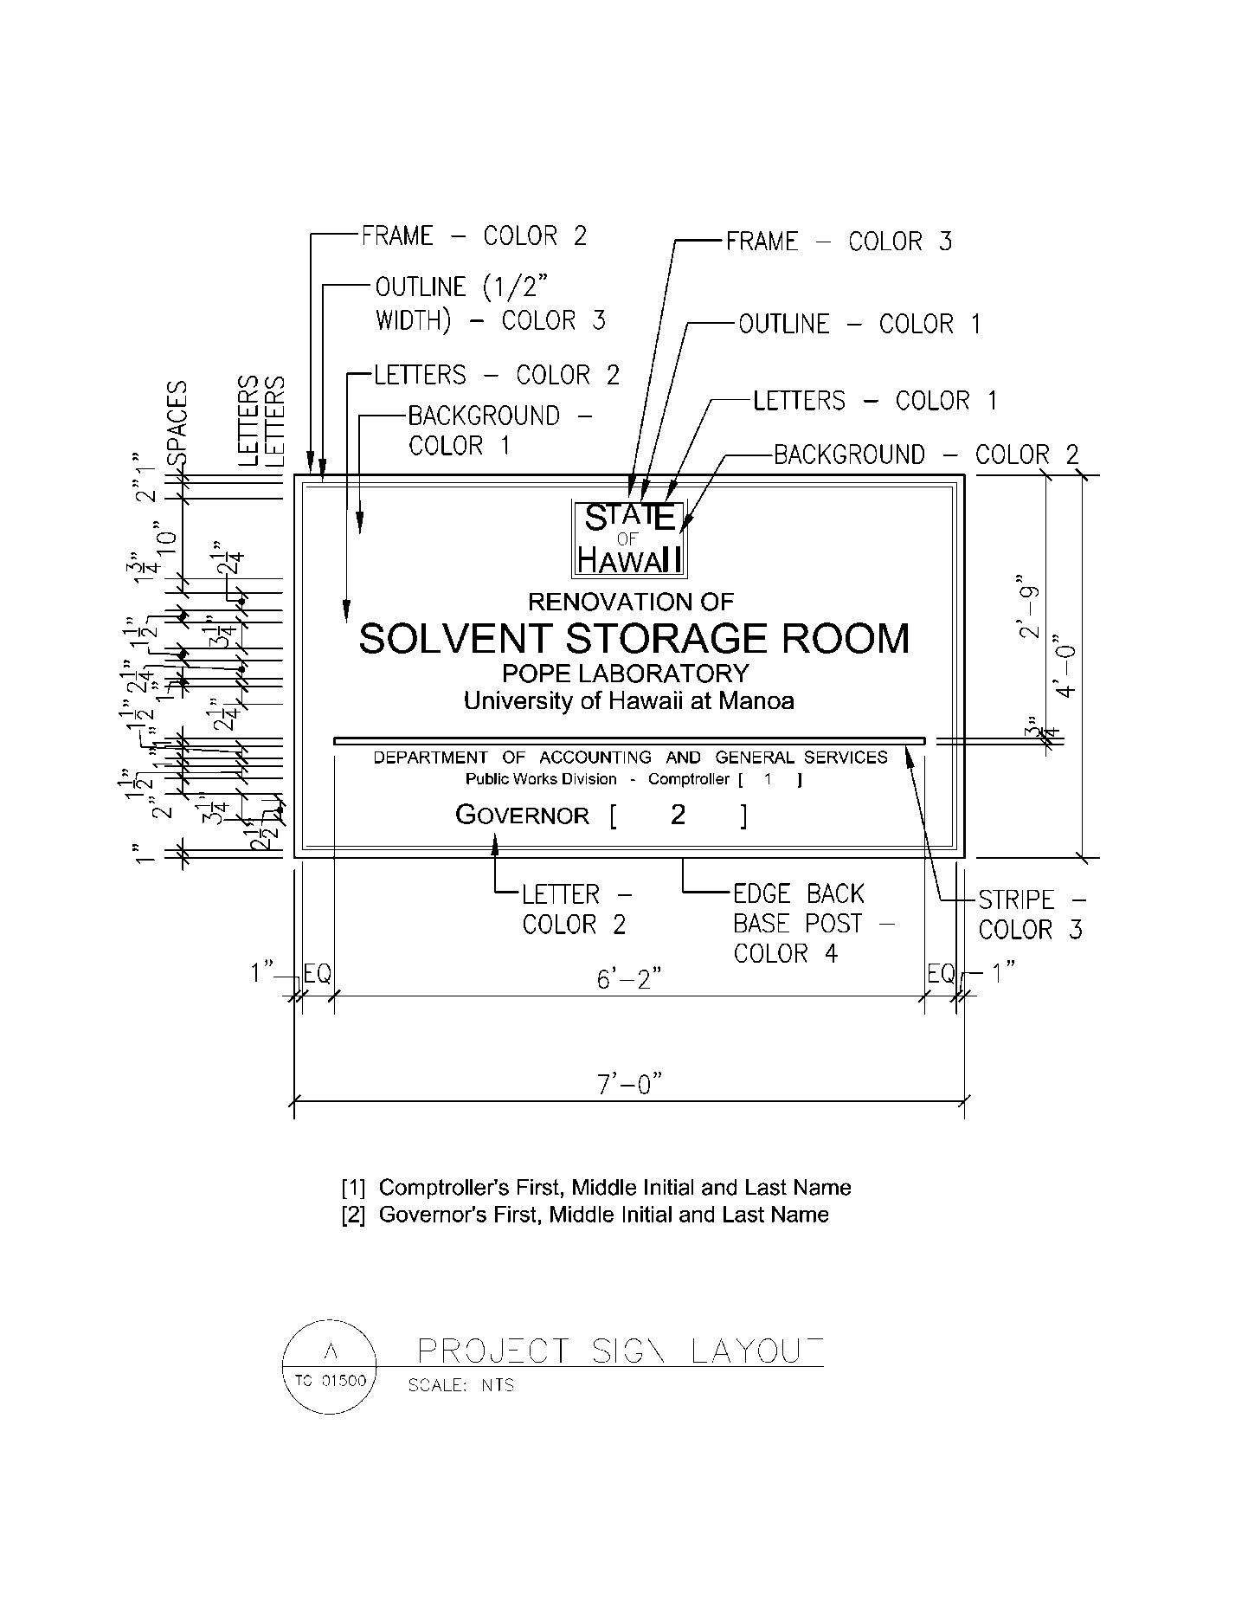

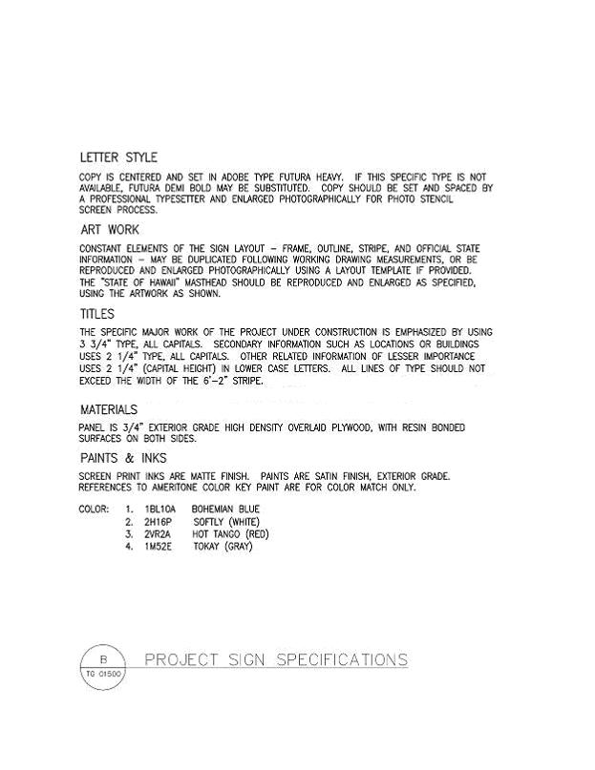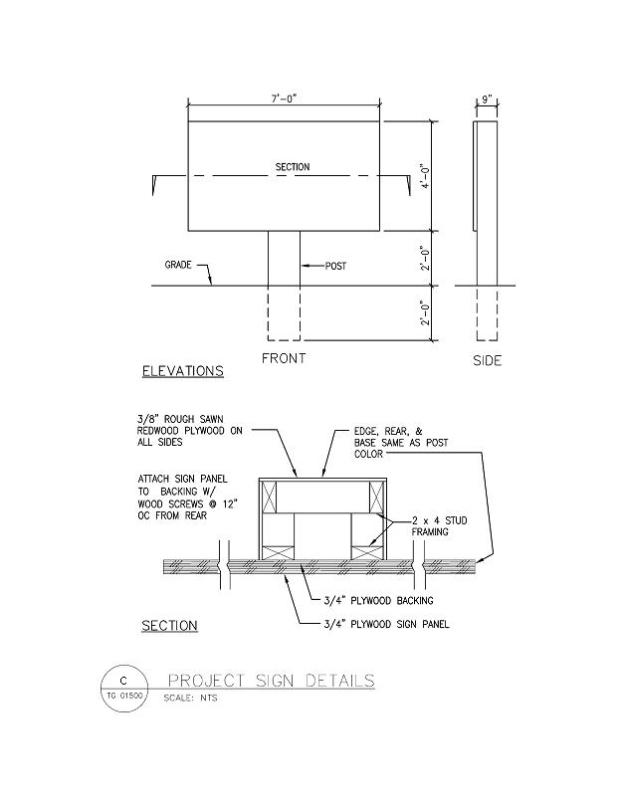

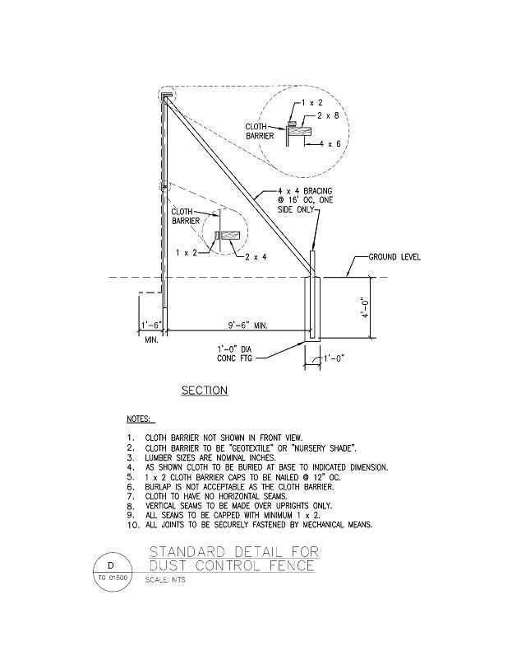

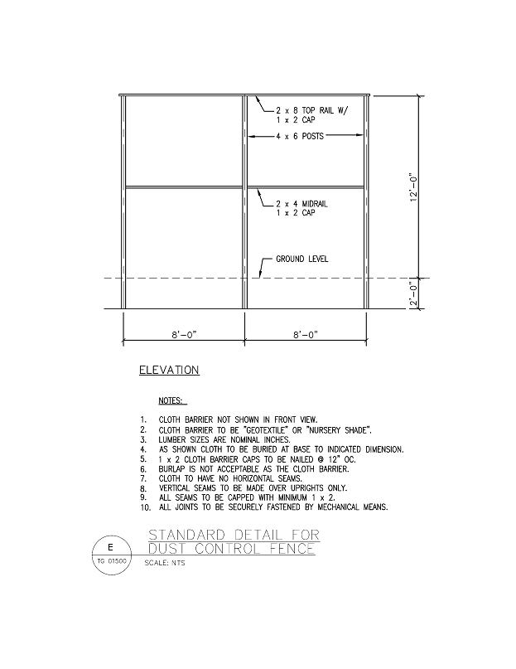

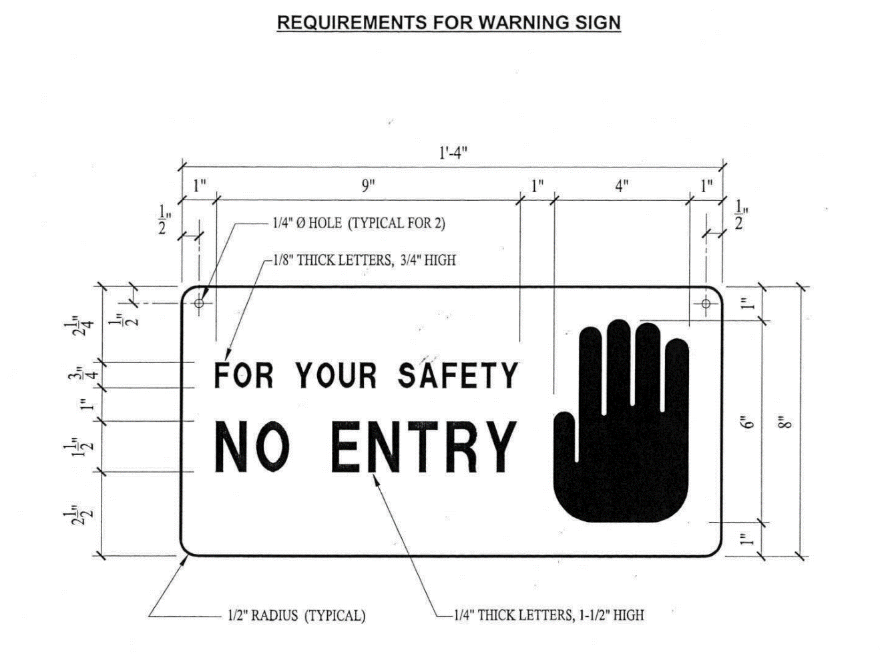
- General Requirements: Furnish all labor, materials and equipments necessary to construct and install warning signs as specified hereinafter.
- Materials
  - Backing: Backing shall be 6061-T6 aluminum 0.032-inch minimum thickness.
  - Paint: Paint shall be satin finish, exterior grade or factory baked enamel or a combination thereof.
- Colors: Signs shall have white background. Remaining items shall be similar to Rust-Oleum Federal Safety Red.
- Requirements for Warning Sign: Message configuration and dimensions shall be in accordance with the attached illustration.
- Installation
  - Signs shall be located at 50-foot intervals around roped off work area or at all entrances in the case of interior work.
  - Signs shall be attached to the rope barrier, rope barrier supports, individual sign supports or buildings. Do not use nails to attach signs to building(s).
- Clean-up: Remove all signs upon completion of project. Repair any damages caused by sign mounting and removal.

DEPARTMENT OF HEALTH
ILLEGAL DUMPING NOTICE

The law requires you to dispose solid waste only at recycling or disposal facilities
permitted by the Department of Health.

“Solid waste” includes municipal refuse, construction and demolition waste, household waste, tires, car batteries, derelict vehicles, green wastes, furniture, and appliances.

Illegal dumping of solid waste
or allowing illegal disposal of solid waste on your property even if contractual or other arrangements are made could subject you to fines from $10,000 to $25,000 per occurrence
and could lead to felony prosecution
in accordance with Chapter 342H, HRS.

Contact the Department of Health,
Solid Waste Section at 586-4226
to report illegal dumping activities
or if you have further questions.

